

**Mawlana Bhashani Science and Technology University**

**Lab-Report**

Report No:07

Course code: ICT-3110

Course title: Operating System Lab

Date of Performance:01/09/2020

Date of Submission:10/09/2020

**Submitted by Submitted To**

Nazrul Islam

Assistant Professor

Dept. of ICT

MBSTU.

Name:Md Asikur Rahman

ID:IT-18025

3rd  year 1st semester

Session: 2017-2018

Dept. of ICT

MBSTU.

# Experiment no : 07

# Experiment Name : Implementation of FCFS Scheduling Algorithm

# Theory:

Given n processes with their burst times, the task is to find average waiting time and average turn around time using FCFS scheduling algorithm.First in, first out (FIFO), also known as first come, first served (FCFS), is the simplest scheduling algorithm. FIFO simply queues processes in the order that they arrive in the ready queue.In this, the process that comes first will executed first and next process starts only after the previous gets fully executed.Here we are considering that arrival time for all processes is 0.

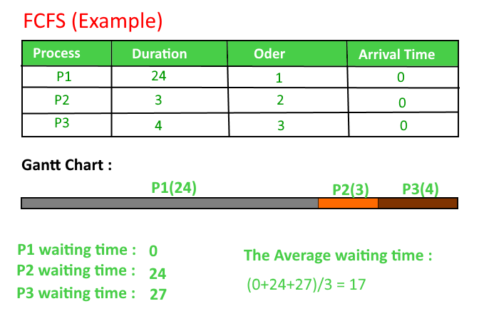

# Working Procedure:

Coding implementation with c++….

*''' Created by asik  
 date:01/09/2020  
'''*#include<iostream>

using namespace std;

int main()

{

    int n,bt[20],wt[20],tat[20],avwt=0,avtat=0,i,j;

    cout<<"Enter total number of processes(maximum 20):";

    cin>>n;

    cout<<"\nEnter Process Burst Time\n";

    for(i=0;i<n;i++)

    {

        cout<<"P["<<i+1<<"]:";

        cin>>bt[i];

    }

    wt[0]=0;    //waiting time for first process is 0

    //calculating waiting time

    for(i=1;i<n;i++)

    {

        wt[i]=0;

        for(j=0;j<i;j++)

            wt[i]+=bt[j];

    }

    cout<<"\nProcess\t\tBurst Time\tWaiting Time\tTurnaround Time";

    //calculating turnaround time

    for(i=0;i<n;i++)

    {

        tat[i]=bt[i]+wt[i];

        avwt+=wt[i];

        avtat+=tat[i];

        cout<<"\nP["<<i+1<<"]"<<"\t\t"<<bt[i]<<"\t\t"<<wt[i]<<"\t\t"<<tat[i];

    }

    avwt/=i;

    avtat/=i;

    cout<<"\n\nAverage Waiting Time:"<<avwt;

    cout<<"\nAverage Turnaround Time:"<<avtat;

    return 0;

}

# Output:

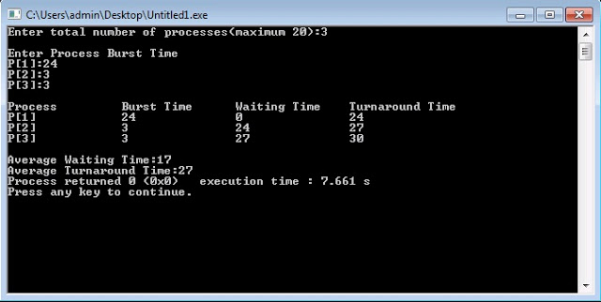

# Discussion:

Here we can learn fcfs algorithm for cpu scheduling and implement in python.

Advances of fcfs algorithm:

1.The simplest form of a CPU scheduling algorithm

2. Easy to program

3. First come first served